SIMATS ENGINEERING
ASSESSMENT TOOL 2: Problem Solving Assignment
COURSE NAME: ARTIFICIAL INTELLIGENCE COURSE CODE: MLA01
AND EXPERT SYSTEMS

COURSE OUTCOME COVERED
CO2: Analyze and select appropriate agent strategies for different types of environments and problem settings. (BTL 3)
Assessment Tool Weightage: 40 %

Total Marks: 100 Time: 60 Mins
No. of Questions: 5
Annexure A
Problem Solving Assignment

Code of Conduct:

I Uppu Sye Kumar/192325121(Name / Reg No) certify that this submission is my original work and that I have adhered to the guidelines specified for this assessment. I understand that any violation of academic integrity rules will result in disciplinary action.
Signature of the student: U.SyeKumar
Criterion | Weightage | Marks Obtained
Problem Analysis and Understanding | 15%
AI Algorithm Selection & Justification | 15%
Algorithm Design / Pseudocode | 25%
Application of AI Concepts (Greedy, A*, CSP,  Minimax, etc.) | 15%
Diagram / State Space / Search Tree  Representation | 10%
Complexity Analysis and Solution Efficiency | 10%
Originality, Critical Thinking, and Presentation | 10%
Total | 100%

Signature of the Faculty Total Marks Awarded

Answer All the Questions
Q.No | Application-Based Question | Major CO2  Concepts
1 | Smart Ambulance Navigation:  An ambulance must travel from a hospital to an emergency location through a city road network. Some roads have higher travel costs, and an estimated distance to the destination is available for each junction. Design a search-based solution to identify the best route. Using the given road network and heuristic values, determine the route selected by your algorithm, show the sequence of junctions explored, calculate the relevant evaluation values, and justify whether the route is optimal.  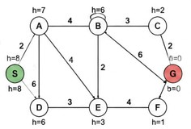 | Informed Search,  A*, Heuristic  Function
2 | Autonomous Warehouse Robot:  A robot has to move from a charging station to a target shelf in a warehouse. The robot does not know all obstacles initially and discovers some obstacles only when it reaches nearby locations. Design an intelligent search strategy for the robot. Demonstrate the robot's decisions for the given grid, explain how it reacts when a new obstacle is discovered, and compare the approach with an offline search strategy.  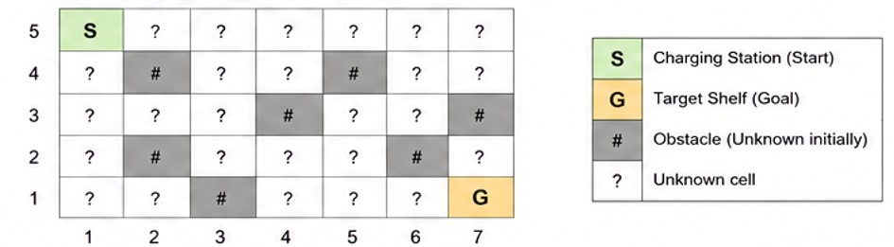 | Online Search  Agents,  Informed Search
3 | University Examination Scheduling:  A university needs to schedule six examinations (E1, E2, E3, E4, E5, and E6) into four available time slots (T1, T2, T3, and T4). Some examinations have common students and therefore cannot be conducted in the same time slot. | CSP, MRV,  Forward  Checking,  Constraints

The following constraints must be satisfied:
- E1 and E2 have common students.
- E1 and E3 have common students.
- E2 and E4 have common students.
- E3 and E5 have common students.
- E4 and E6 have common students.
- E2 and E5 have common students.
The university has three examination halls with the following capacities:

 |  | Examination Hall |  |  |  | Capacity
 |  | Hall A |  |  |  | 120 students
 |  | Hall B |  |  |  | 90 students
 |  | Hall C |  |  |  | 60 students
 |  | Examination | E1 | E2 | E3 | E4 | E5 | E6 | CSP) by  (MRV) timetable.  provide  hall-capacity
 |  | Number of  Students | 100 | 80 | 70 | 60 | 90 | 50
Tasks:
- Formulate the problem as a Constraint Satisfaction Problem ( clearly defining the variables, domains, and constraints.
- Use Backtracking with the Minimum Remaining Values heuristic and Forward Checking to obtain a valid examination
- Show the domain of each variable after every assignment and the final timetable, ensuring that all student-conflict and constraints are satisfied.
4 |  | Game-Playing AI:  You are developing an AI opponent for a board game. The current game position produces the following possible moves and terminal scores in the supplied game tree. Determine the move the AI should make by applying Minimax. Then apply Alpha-Beta Pruning and identify the branches that do not need to be evaluated. Explain how pruning improves the efficiency of the game-playing agent. |  |  |  |  |  |  |  | Game Playing,  Minimax,  Alpha-Beta  Pruning
 | 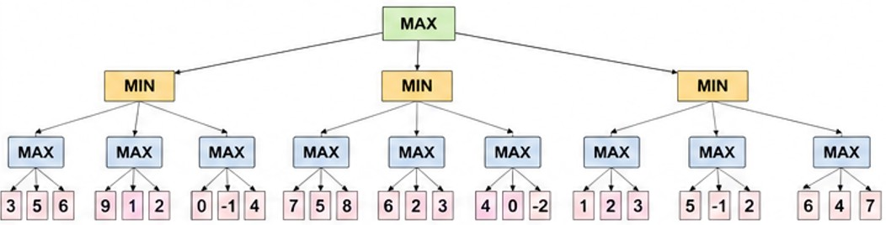
5 | Delivery Route Optimization:  A logistics company wants to minimize the total distance travelled by a delivery vehicle visiting multiple customers. An initial route and several neighboring routes are provided. Design an optimization strategy to improve the route. Apply the strategy step-by-step to the given routes, determine the final route, explain whether it represents a global optimum, and suggest how the algorithm could escape a local optimum.  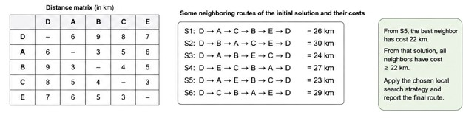 |  |  |  |  |  |  |  |  |  | Local Search,  Optimization,  Hill Climbing

Q1. Smart Ambulance Navigation
Technique: A* Search and Heuristic Function
1. Problem Statement
An ambulance must find a minimum-cost route from the hospital S to the emergency location G using a weighted city road network. Each junction has a heuristic estimate of its remaining distance to G. A* is used to combine the actual path cost and the heuristic estimate.
2. Problem Analysis
Component | Description
Initial state | S (hospital)
Goal state | G (emergency location)
State space | S, A, B, C, D, E, F, G
Operators | Travel through connected roads
Path cost | Road travel cost
Objective | Minimum-cost route
3. Heuristic Values
Node | S | A | B | C | D | E | F | G
h(n) | 8 | 7 | 6 | 2 | 6 | 3 | 1 | 0
4. Road Costs
Road | S-A | S-D | A-B | A-D | A-E | D-E | B-E | B-C | B-G | C-G | E-F | F-G
Cost | 2 | 6 | 4 | 6 | 4 | 3 | 2 | 3 | 6 | 2 | 4 | 2
5. A* Formula
f(n) = g(n) + h(n), where g(n) is the actual cost from S to n and h(n) is the estimated remaining cost to G.
6. Search Trace
Expansion | Node | g(n) | h(n) | f(n)
1 | S | 0 | 8 | 8
2 | A | 2 | 7 | 9
3 | E | 6 | 3 | 9
4 | F | 10 | 1 | 11
5 | B | 6 | 6 | 12
6 | C | 9 | 2 | 11
7 | G | 11 | 0 | 11
7. Selected Route
S → A → B → C → G
Total cost = 2 + 4 + 3 + 2 = 11.
8. A* Pseudocode
1. Put S in OPEN and set g(S)=0.
2. Calculate f(n)=g(n)+h(n).
3. Select the OPEN node with minimum f(n).
4. If it is G, return the path.
5. Expand it and update successors with cheaper g-values.
6. Repeat until G is selected.
9. Optimality
With an admissible heuristic, h(n) never overestimates the true remaining cost. Therefore A* is complete and optimal under the standard conditions.
10. Complexity
Property | Analysis
Time | O(b^d) worst case
Space | O(b^d)
Optimality | Yes with admissible heuristic
Completeness | Yes under standard conditions
11. Advantages and Limitations
Uses both actual cost and estimated remaining cost.
Suitable for weighted route planning.
Can find an optimal route with an admissible heuristic.
Memory usage can become large.
Performance depends on heuristic quality.
Q2. Autonomous Warehouse Robot
Technique: Online Search Agent
1. Problem Statement
The robot moves from a charging station S to a target shelf G in a partially known warehouse. It discovers some obstacles only when it reaches nearby cells. Therefore it must sense, act, update its map, and re-plan during execution.
2. Problem Analysis
Component | Description
Initial state | S
Goal | G
Environment | Partially known grid
Movement | Up, Down, Left, Right
Unknown information | Some obstacles
Strategy | Online search
3. Grid Representation
Row | C1 | C2 | C3 | C4 | C5 | C6 | C7
1 | S | ? | ? | ? | ? | ? | ?
2 | ? | # | ? | ? | # | ? | ?
3 | ? | ? | ? | ? | ? | ? | #
4 | ? | # | ? | ? | ? | # | ?
5 | ? | ? | # | ? | ? | ? | G
4. Heuristic
For a four-direction grid, Manhattan distance can be used: h(n)=|x_n−x_G|+|y_n−y_G|.
For S=(1,5) and G=(7,1), h(S)=|1−7|+|5−1|=10.
5. Online Search Algorithm
Sense → Plan → Move → Observe → Re-plan. At each step, sense neighboring cells, update the local map, choose a legal promising action, move, and repeat. When a new obstacle is detected, mark it blocked and immediately re-plan.
6. Example Execution
A safe route consistent with the supplied grid is: S → (2,5) → (3,5) → (4,5) → (4,4) → (4,3) → (5,3) → (5,2) → (5,1) → (6,1) → G.
Step | State | Observation / Decision
1 | S | Nearby cells initially unknown; move toward a promising cell.
2 | (2,5) | Path available; continue.
3 | (3,5) | Path available; continue.
4 | (4,5) | Sense surroundings and update map.
5 | Near unknown obstacle | If blocked cell is discovered, mark it #.
6 | New state | Remove blocked action and re-plan.
7 | Near G | Goal becomes reachable.
8 | G | Stop.
7. Online vs Offline Search
Feature | Online Search | Offline A*
Environment | Partially known | Known before search
Planning | During execution | Before execution
New obstacle | Can react and re-plan | Requires re-planning
Adaptability | High | Lower
Optimality | Not guaranteed | Can be optimal
8. Complexity and Limitations
Complexity depends on the number of states explored and re-planning operations. Online search is adaptive but may produce longer routes and repeated computation.
Q3. University Examination Scheduling
Technique: Constraint Satisfaction Problem (CSP), Backtracking, MRV and Forward Checking
1. CSP Formulation
Variables: E1, E2, E3, E4, E5, E6. Domain of every examination initially: {T1,T2,T3,T4}.
2. Student-Conflict Constraints
E1 ≠ E2
E1 ≠ E3
E2 ≠ E4
E3 ≠ E5
E4 ≠ E6
E2 ≠ E5
3. Hall Capacities and Examination Sizes
Examination | E1 | E2 | E3 | E4 | E5 | E6
Students | 100 | 80 | 70 | 60 | 90 | 50

Hall | Capacity
A | 120
B | 90
C | 60
4. Hall Eligibility
Exam | Students | Eligible Halls
E1 | 100 | A
E2 | 80 | A, B
E3 | 70 | A, B
E4 | 60 | A, B, C
E5 | 90 | A, B
E6 | 50 | A, B, C
5. Constraint Graph
Edges: E1–E2, E1–E3, E2–E4, E3–E5, E4–E6, E2–E5.
6. MRV + Forward Checking Trace
Step | Assignment | E1 | E2 | E3 | E4 | E5 | E6
0 | Initial | T1,T2,T3,T4 | T1,T2,T3,T4 | T1,T2,T3,T4 | T1,T2,T3,T4 | T1,T2,T3,T4 | T1,T2,T3,T4
1 | E2=T1 | T2,T3,T4 | T1 | T1,T2,T3,T4 | T2,T3,T4 | T2,T3,T4 | T1,T2,T3,T4
2 | E1=T2 | T2 | T1 | T1,T3,T4 | T2,T3,T4 | T2,T3,T4 | T1,T2,T3,T4
3 | E3=T1 | T2 | T1 | T1 | T2,T3,T4 | T2,T3,T4 | T1,T2,T3,T4
4 | E4=T2 | T2 | T1 | T1 | T2 | T2,T3,T4 | T1,T3,T4
5 | E5=T2 | T2 | T1 | T1 | T2 | T2 | T1,T3,T4
6 | E6=T1 | T2 | T1 | T1 | T2 | T2 | T1
7. Final Timetable with Hall Assignment
Time Slot | Hall A | Hall B | Hall C
T1 | E2 – 80 | E3 – 70 | E6 – 50
T2 | E1 – 100 | E5 – 90 | E4 – 60
T3 | — | — | —
T4 | — | — | —
8. Verification
E1≠E2: T2≠T1
E1≠E3: T2≠T1
E2≠E4: T1≠T2
E3≠E5: T1≠T2
E4≠E6: T2≠T1
E2≠E5: T1≠T2
All hall capacities are satisfied. Therefore the timetable is valid.
9. CSP Pseudocode
1. If all exams are assigned, return the assignment.
2. Select an unassigned exam using MRV.
3. Try each legal time slot.
4. Assign the slot and forward-check neighboring domains.
5. If no domain becomes empty, recursively continue.
6. If a conflict occurs, undo the assignment and try the next value.
10. Complexity
Worst-case backtracking complexity is O(d^n). Here n=6 examinations and d=4 time slots, giving an unpruned search space of 4^6=4096 assignments. MRV and Forward Checking reduce practical search.
Q4. Game-Playing AI
Technique: Minimax and Alpha–Beta Pruning
1. Game Tree Values
The supplied tree has three MIN branches. The MAX child groups are:
Root Branch | MAX child 1 | MAX child 2 | MAX child 3
Left | 3,5,6 | 9,1,2 | 0,1,4
Middle | 7,5,8 | 6,2,3 | 4,0,2
Right | 1,2,3 | 5,1,2 | 6,4,7
2. Minimax Evaluation
Root Branch | MAX results | MIN result
Left | 6, 9, 4 | 4
Middle | 8, 6, 4 | 4
Right | 3, 5, 7 | 3
Root is MAX, so MAX(4,4,3)=4. The Left and Middle moves tie. With left-to-right tie-breaking, select Left.
3. Alpha–Beta Pruning
Pruning occurs when β ≤ α. With left-to-right traversal, two leaves in the first MIN branch are pruned after the first value 9 exceeds β=6. In the third MIN branch, after the first MAX child returns 3, β=3 and root α=4, so the remaining two MAX branches are pruned.
Algorithm | Leaf Nodes Evaluated | Leaves Pruned
Minimax | 27 | 0
Alpha–Beta | 19 | 8
Reduction = 8/27 × 100 ≈ 29.63%. Alpha–Beta gives the same decision while evaluating fewer nodes.
4. Pseudocode
MINIMAX(node): if terminal return score; if MAX return maximum child value; otherwise return minimum child value.
ALPHA-BETA(node, α, β): evaluate children while updating α at MAX and β at MIN; stop when β≤α.
5. Complexity
Algorithm | Time
Minimax | O(b^d)
Alpha–Beta worst case | O(b^d)
Alpha–Beta best case | approximately O(b^(d/2))
Alpha–Beta pruning reduces computation and permits deeper search with the same minimax result.
Q5. Delivery Route Optimization
Technique: Hill Climbing / Local Search
1. Problem Statement
A logistics company wants to minimize the total route cost for visiting the customers. Hill Climbing repeatedly replaces the current route with a better neighboring route until no improving neighbor remains.
2. Distance Matrix Supplied
From/To | D | A | B | C | E
D | – | 6 | 9 | 8 | 7
A | 6 | – | 3 | 5 | 6
B | 9 | 3 | – | 4 | 5
C | 8 | 5 | 4 | – | 3
E | 7 | 6 | 5 | 3 | –
3. Given Neighboring Routes
Route | Sequence | Printed Cost
S1 | D→A→C→B→E→D | 26 km
S2 | D→B→A→C→E→D | 30 km
S3 | D→A→B→E→C→D | 24 km
S4 | D→E→C→B→A→D | 27 km
S5 | D→A→E→B→C→D | 23 km
S6 | D→C→B→A→E→D | 29 km
4. Hill-Climbing Trace
Step | Current Solution | Cost | Best Neighbor | Action
1 | S5 | 23 km | 22-km neighbor | Move
2 | 22-km solution | 22 km | All neighbors ≥22 km | Stop
The assessment source explicitly states that from S5 the best neighboring solution has cost 22 km and that all neighbors from that solution have cost at least 22 km.
5. Important Data Note
The source's printed route-cost list and distance matrix are internally inconsistent for some routes. The 22-km neighbor is not given a route sequence/name in the source. Therefore this document does not invent a route name for the final 22-km solution; it reports the source-supported result exactly.
6. Is 22 km a Global Optimum?
No global-optimum claim can be made from the supplied neighborhood alone. Since every neighbor of the 22-km state has cost ≥22 km, it is a local minimum under the stated neighborhood.
7. Escaping a Local Optimum
Random Restart: start Hill Climbing from different initial routes.
Simulated Annealing: occasionally accept worse moves to escape local minima.
Stochastic Hill Climbing: randomly choose among improving neighbors.
Sideways Moves: permit equal-cost moves to cross plateaus.
8. Pseudocode
1. current ← initial route.
2. Generate neighboring routes.
3. Select the best neighbor.
4. If it has lower cost, make it current.
5. Otherwise return current.
6. Repeat until no improvement is possible.
9. Complexity
Approximately O(Ik), where I is the number of iterations and k is the number of neighbors evaluated per iteration, plus route-cost calculation.

EVALUATION RUBRICS

Criteria | Weightage  (%) | Excellent (Full Marks) | Good | Average | Poor
CSP Problem  Formulation | 20% | 4% – Clearly defines all variables, domains, and problem objectives correctly. | 3% – Defines most variables and domains with minor errors. | 2% – Partial formulation with some missing components. | 0–1% –  Incorrect or incomplete formulation.
Constraint  Identification  &  Representatio n | 20% | 4% –  Accurately  identifies all student-confli ct and hall-capacity constraints and represents them correctly. | 3% –  Identifies most constraints with minor errors. | 2% –  Identifies some  constraints but misses important relationships. | 0–1% –  Constraints are largely incorrect or missing.
Application of  Backtracking,  MRV &  Forward  Checking | 30% | 6% –  Correctly applies  Backtracking,  MRV, and  Forward  Checking with clear and logical steps. | 4.5% – Applies the techniques correctly with minor mistakes. | 3% – Partial application with unclear or inconsistent steps. | 0–1.5% –  Incorrect or inappropriate application of  CSP  techniques.
Step-by-Step  Execution &  Domain  Updates | 20% | 4% – Provides a complete, logical execution trace and correctly updates domains after every assignment. | 3% – Mostly correct execution with minor gaps. | 2% – Provides limited steps with some incorrect domain updates. | 0–1% –  Incomplete or incorrect execution.
Final  Timetable,  Accuracy &  Justification | 10% | 2% – Produces a valid conflict-free timetable satisfying all constraints and capacity requirements with clear justification. | 1.5% – Valid timetable with minor errors in justification. | 1% – Partially valid timetable with some  constraint violations. | 0–0.5% – Invalid or missing timetable.

